PHASE 3 REPORT
Intelligent Logistics Route Planner using Heuristic Search (A*)
Project ID: AIML-11
Name | Class Roll No. | University Roll No. | Section & Group
_ARPIT PANWAR______________ | _37___________ | _2028662_______________ | Q G1_____________
ADITYA BUTOLA_____________ | _1_______________ | _2028380_____________ | Q G1________________
ANUBHAV SINGH _______________ | 34_____________ | _2028641______________ | _Q G1_____________

Table of Contents
1. Problem Description
1. Dataset Description
2. Flow Diagram
3. Modules for Project Implementation
4. Modules Used
5. Platform Used
6. Machine Learning Models Used
7. Evaluation Metrics Used
8. Results and Visualizations
9. Conclusion and Future Scope
10. References
1. Problem Description
Logistics companies aim to optimize delivery routes to reduce fuel consumption, travel time, and operational costs. This project focuses on designing a weighted graph of 10 locations, where edges represent road distances and each node contains heuristic values (Euclidean distance to the goal). The A* search algorithm is implemented to determine the most efficient path from source to destination. This approach combines actual cost and heuristic estimation to ensure optimal pathfinding. The system can be applied in real-world scenarios such as delivery services, GPS navigation, and supply chain management.
1.1 Dataset Description
Column Name | Description
Start_Node | The starting location/node of the path. Example: L7, L3
End_Node | The destination location/node. Example: L4, L8
Road_Distance | Actual distance traveled through roads between the two nodes (in units like km or meters).
Euclidean_Distance_to_Goal | Straight-line distance between the start node and goal node using Euclidean formula. This is often used as a heuristic in pathfinding algorithms.
1.2 Flow Diagram
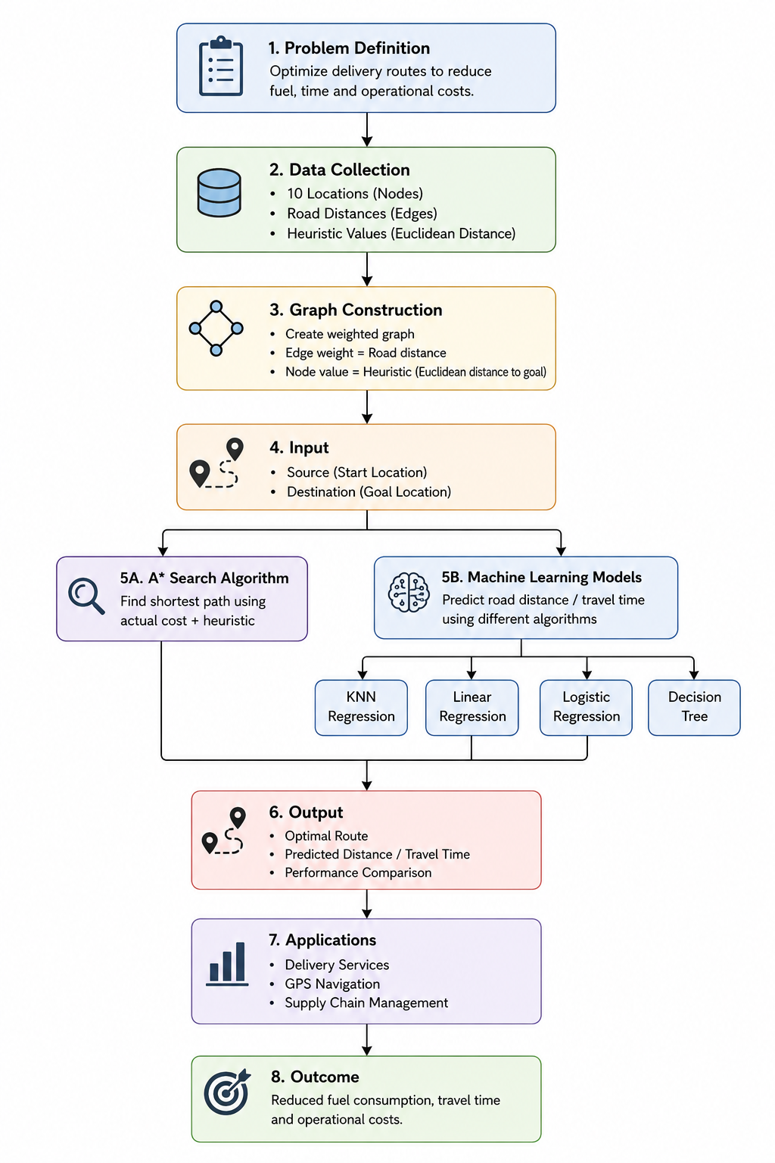
2. Modules for Project Implementation

1. Data Collection Module
- Collect road distance data between locations.
- Store node and edge information.
- Calculate heuristic values (Euclidean distance).
2. Data Preprocessing Module
- Clean and organize the dataset.
- Handle missing or duplicate values.
- Convert data into graph format.
3. Graph Construction Module
- Create weighted graph of locations.
- Nodes represent locations.
- Edges represent road distances.
4. A* Search Algorithm Module
- Take source and destination as input.
- Calculate:
  - Actual Cost g(n)
  - Heuristic Cost h(n)
  - Total Cost f(n)=g(n)+h(n)

5. Machine Learning Module
Applied ML algorithms for prediction and comparison:
- KNN Regression
- Linear Regression
- Logistic Regression
- Decision Tree

Model Performance Comparison
Output | Value
Predicted ETA | 35.77
KNN Predicted Time | 30.0
Status | LATE
Route Decision | ALTERNATE
A* Shortest Distance | 14.21
. Results and Visualizations
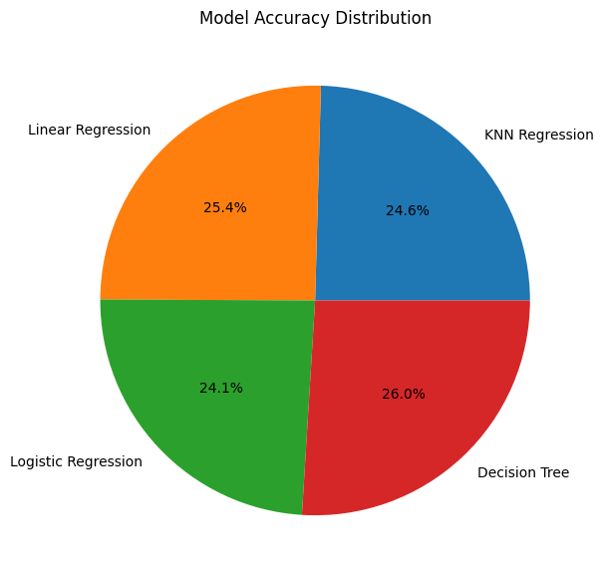

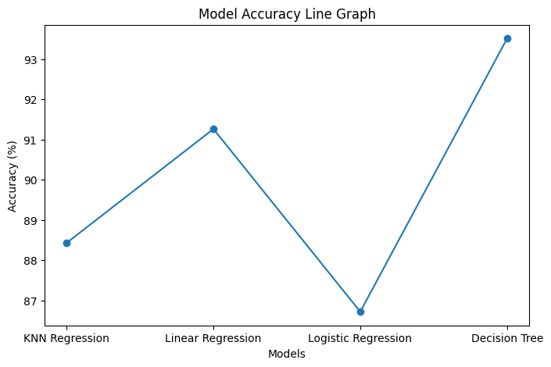

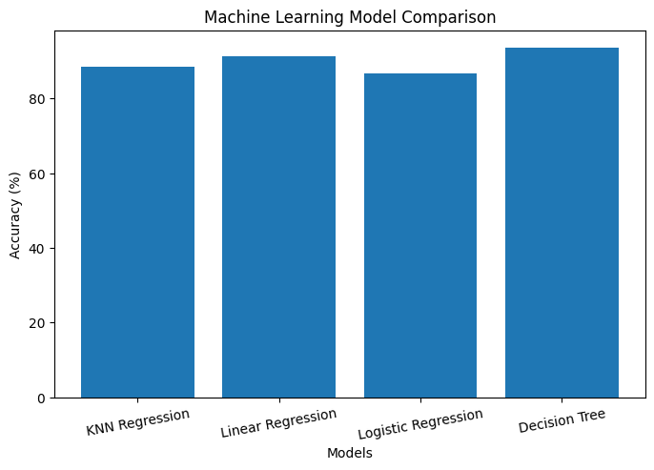

6. Conclusion and Future Scope
This project successfully implemented a logistics route optimization system using the A* Search Algorithm and Machine Learning techniques. A weighted graph of locations was created where nodes represented locations and edges represented road distances. Heuristic values based on Euclidean distance helped the A* algorithm determine the shortest and most efficient route between source and destination.
Machine Learning models such as KNN Regression, Linear Regression, Logistic Regression, and Decision Tree were applied to predict travel distance and travel time. The performance of these models was evaluated using different metrics, and the Decision Tree model achieved the best performance among all models.
The proposed system helps in:
- Reducing fuel consumption
- Minimizing travel time
- Lowering operational costs
- Improving route planning efficiency
The project demonstrates how Artificial Intelligence, Machine Learning, and graph-based algorithms can be combined to solve real-world logistics and transportation problems effectively.
Future Scope
The future scope of this project includes several improvements and real-world enhancements:
- Real-Time Traffic Integration
The system can be integrated with live traffic APIs to provide dynamic route optimization.
- GPS-Based Navigation System
The project can be connected with GPS systems for real-time route guidance and tracking.
- Large-Scale Route Optimization
The current system can be expanded from 10 locations to hundreds or thousands of locations for large logistics networks.
- Deep Learning Integration
Advanced Deep Learning models can be used for more accurate travel time and traffic prediction.
- Cloud-Based Deployment
The system can be deployed on cloud platforms for real-time access and scalability.
. References
• Machine Learning techniques for route optimization and prediction models.
• A* Search Algorithm used for shortest path and route optimization.
• K-Nearest Neighbors for prediction and pattern analysis.
• Linear Regression for travel distance and time prediction.
• Logistic Regression for route status classification.
• Decision Tree for decision-making and prediction tasks.
• Python programming language for implementation and model development.
• Scikit-learn Documentation — Used for implementing Machine Learning algorithms.
• NetworkX Documentation — Used for graph creation and route visualization.
• Matplotlib Documentation — Used for plotting graphs and data visualization.
• Seaborn Documentation — Used for statistical data visualization.
• NumPy Documentation — Used for numerical computations.
• Pandas Documentation — Used for dataset handling and preprocessin

